Predictive analytics is the branch of the advanced analytics which is used to make predictions about unknown future events. Predictive analytics uses many techniques from data mining, statistics, modeling, machine learning, and artificial intelligence to analyze current data to make predictions about future.

It uses a number of data mining, predictive modeling and analytical techniques to bring together the management, information technology, and modeling business process to make predictions about future. The patterns found in historical and transactional data can be used to identify risks and opportunities for future.

Predictive analytics models capture relationships among many factors to assess risk with a particular set of conditions to assign a score, or weightage. By successfully applying predictive analytics the businesses can effectively interpret big data for their benefit.

The data mining and text analytics along with statistics, allows the business users to create predictive intelligence by uncovering patterns and relationships in both the structured and unstructured data. The data which can be used readily for analysis are structured data, examples like age, gender, marital status, income, sales. Unstructured data are textual data in call center notes, social media content, or other type of open text which need to be extracted from the text, along with the sentiment, and then used in the model building process.

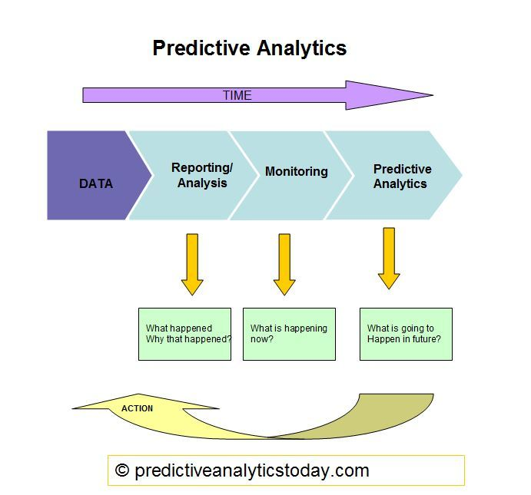Predictive analytics allows organizations to become proactive, forward looking, anticipating outcomes and behaviors based upon the data and not on a hunch or assumptions. Prescriptive analytics, goes further and suggest actions to benefit from the prediction and also provide decision options to benefit from the predictions and its implications.

## Predictive Analytics Process

### 1.Define Project:

Define the project outcomes, deliverables, scoping of the effort, business objectives, identify the data sets which are going to be used.

### 2.Data Collection:

Data Mining for predictive analytics prepares data from multiple sources for analysis. This provides a complete view of the customer interactions.

### 3. Data Analysis:

Data Analysis is the process of inspecting, cleaning, transforming, and modeling data with the objective of discovering useful information, arriving at conclusions.

### 4.Statistics:

Statistical Analysis enables to validate the assumptions, hypotheses and test them with using standard statistical models.

### 5.Modeling:

Predictive Modeling provides the ability to automatically create accurate predictive models about future. There are also options to choose the best solution with multi model evaluation.

### 6.Deployment:

Predictive Model Deployment provides the option to deploy the analytical results in to the every day decision making process to get results, reports and output by automating the decisions based on the modeling.

### 7.Model Monitoring:

Models are managed and monitored to review the model performance to ensure that it is providing the results expected.

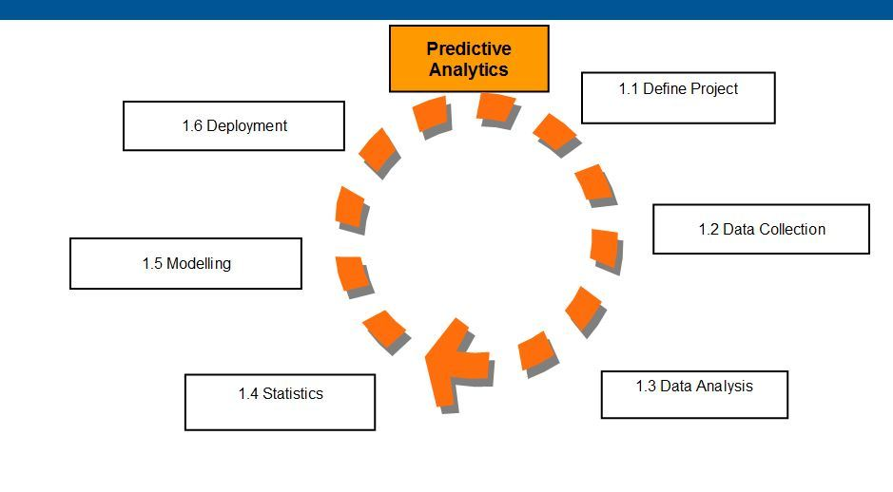

## Applications of Predictive Analytics

### 1. Customer relationship management (CRM)

Predictive analysis applications are used to achieve CRM objectives such as marketing campaigns, sales, and customer services. Analytical customer relationship management can be applied throughout the customers life cycle, right from acquisition, relationship growth, retention, and win back.

### 2. Health Care

Predictive analysis applications in health care can determine the patients who are at the risk of developing certain conditions such as diabetes, asthma and other lifetime illnesses. The clinical decision support systems incorporate predictive analytics to support medical decision making at the point of care.

### 3. Collection Analytics

Predictive analytics applications optimize the allocation of collection resources by identifying the effective collection agencies, contact strategies, legal actions to increase the recovery and also reducing the collection costs.

### 4. Cross Sell

Predictive analytics applications analyze customers spending, usage and other behavior, leading to efficient cross sales, or selling additional products to current customers for an organization that offers multiple products

### 5. Fraud detection

Predictive analytics applications can find inaccurate credit applications, fraudulent transactions both done offline and online, identity thefts and false insurance claims.

### 6. Risk management

Predictive analytics applications predicts the best portfolio to maximize return in capital asset pricing model and probabilistic risk assessment to yield accurate forecasts.

### 7.Direct Marketing

Predictive analytics can also help to identify the most effective combination of product versions, marketing material, communication channels and timing that should be used to target a given consumer.

### 8.Underwriting

Predictive analytics can help underwrite the quantities by predicting the chances of illness, default, bankruptcy. Predictive analytics can streamline the process of customer acquisition by predicting the future risk behavior of a customer using application level data.

### What is predictive analytics used for?

Predictive analytics can be used to streamline operations, boost revenue, and mitigate risk for almost any business or industry, including banking, retail, utilities, public sector, healthcare, and manufacturing. Sometimes augmented analytics are used, which uses big data machine learning. Here are some more use case examples, including data lake analytics.

##### Fraud detection

Predictive analytics examines all actions on a company’s network in real time to pinpoint abnormalities that indicate fraud and other vulnerabilities.

##### **Operations improvement**

Companies use predictive analytics models to forecast inventory, manage resources, and operate more efficiently.

##### **Customer segmentation**

By dividing a customer base into specific groups, marketers can use predictive analytics to make forward-looking decisions to tailor content to unique audiences.

##### **Conversion and purchase prediction**

Companies can take actions, like retargeting online ads to visitors, with data that predicts a greater likelihood of conversion and purchase intent.

##### **Risk reduction**

Credit scores, insurance claims, and debt collections all use predictive analytics to assess and determine the likelihood of future defaults.

##### **Predictive maintenance**

Organizations use data to predict when routine equipment maintenance will be required and can then schedule it before a problem or malfunction arises.